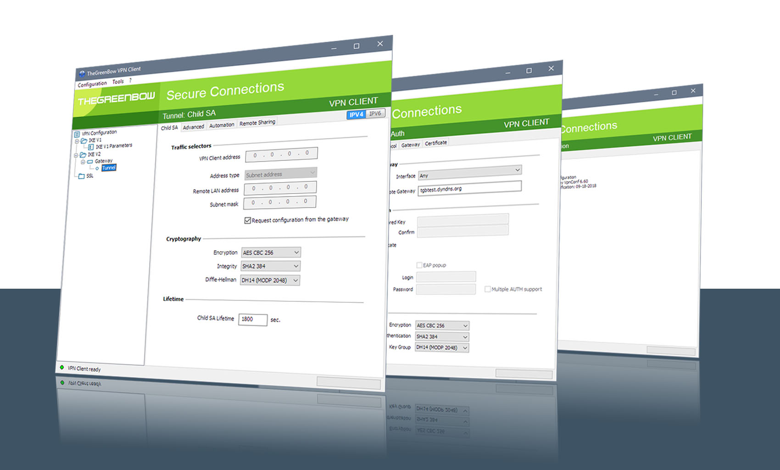

TheGreenBow IPsec VPN Client

Configuration Guide
YYYYY
Written by: John Writer or Engineering Team
Company: www.mycompany.com

Website: www.thegreenbow.com
Contact: support@thegreenbow.com

Table of Contents

1 Introduction 3
1.1 Goal of this document 3
1.2 VPN Network topology 3
1.3 YYYYYY Restrictions 3
1.4 YYYYYY VPN Gateway 3
1.5 YYYYYY VPN Gateway product info 3
2 YYYYYY VPN configuration 4
3 TheGreenBow IPsec VPN Client configuration 5
3.1 VPN Client Phase 1 (IKE) Configuration 5
3.2 VPN Client Phase 2 (IPsec) Configuration 6
3.3 Open IPsec VPN tunnels 6
4 Tools in case of trouble 7
4.1 A good network analyser: Wireshark 7
5 VPN IPsec Troubleshooting 8
5.1 “PAYLOAD MALFORMED” error (wrong Phase 1 [SA]) 8
5.2 “INVALID COOKIE” error 8
5.3 “no keystate” error 8
5.4 “received remote ID other than expected” error 8
5.5 “NO PROPOSAL CHOSEN” error 9
5.6 “INVALID ID INFORMATION” error 9
5.7 I clicked on “Open tunnel”, but nothing happens. 9
5.8 The VPN tunnel is up but I can’t ping ! 10
6 Contacts 11

Introduction

Goal of this document
This configuration guide describes how to configure TheGreenBow IPsec VPN Client software with a YYYYYY VPN router to establish VPN connections for remote access to corporate network.

VPN Network topology
In our VPN network example (diagram hereafter), we will connect TheGreenBow IPsec VPN Client software to the LAN behind the YYYYYY router. The VPN client is connected to the Internet with a DSL connection or through a LAN. All the addresses in this document are given for example purpose.
IPsec VPN Client
as seen on LAN

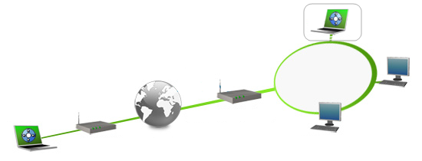
IPsec VPN Client
(Remote)

192.168.0.3
192.168.1.78
YYYYYY

192.168.1.1
mygateway.dyndns.org
Internet

YYYYYY Restrictions
Depending on the firmware version, YYYYYY may not support NAT-T and as a consequence the IPsec VPN Client software could not connect if standing on a LAN behind (e.g. router at home, ..).

YYYYYY VPN Gateway
Our tests and VPN configuration have been conducted with YYYYYY firmware release xxx.yy.zzz.

YYYYYY VPN Gateway product info
It is critical that users find all necessary information about YYYYYY VPN Gateway. All product info, User Guide and knowledge base for the YYYYYY VPN Gateway can be found on the YYYYYY website: www.YYYYYY.com/YYYYYY.html.

YYYYYY Product page | www.YYYYYY.com/YYYYYY.html
YYYYYY User Guide | www.YYYYYY.com/YYYYYY/YYYYYY_user_guide.pdf
YYYYYY FAQ/Knowledge Base | www.YYYYYY.com/YYYYYY.html

YYYYYY VPN configuration

This section describes how to build an IPsec VPN configuration with your YYYYYY VPN router.
Once connected to your YYYYYY VPN gateway, you must select “Security” and “VPN” tabs.

TheGreenBow IPsec VPN Client configuration

This section describes the required configuration to connect to a YYYYYY VPN router via VPN connections.
To download the latest release of TheGreenBow IPsec VPN Client software, please go to www.thegreenbow.com/vpn_down.html.

VPN Client Phase 1 (IKE) Configuration

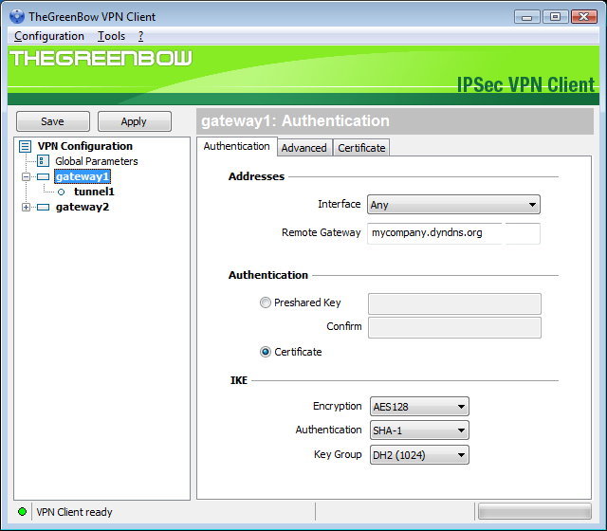
The remote VPN Gateway IP address is either an explicit IP address or a DNS Name

0123456789
Phase 1 configuration

You may use either Preshared key, Certificates, USB Tokens, OTP Token (One Time Password) or X-Auth combined with RADIUS Server for User Authentication with the YYYYYY router. This configuration is one example of what can be accomplished in term of User Authentication. You may want to refer to either the YYYYYY router user guide or TheGreenBow IPsec VPN Client software User Guide for more details on User Authentication options.

VPN Client Phase 2 (IPsec) Configuration

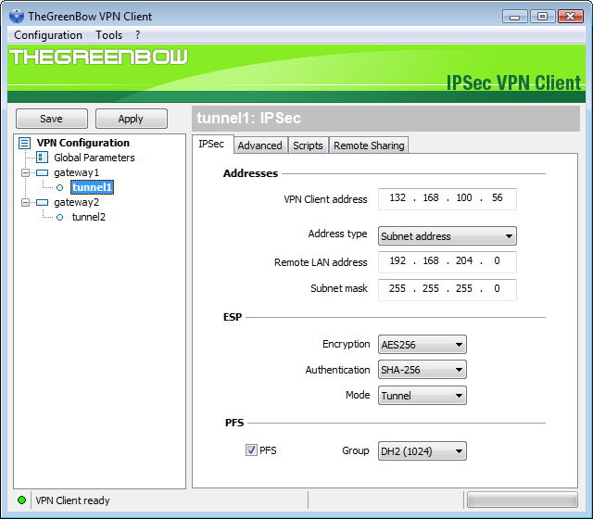
VPN Client Virtual IP address
Enter the IP address (and subnet mask)
of the remote LAN.
Phase 2 Configuration

Open IPsec VPN tunnels
Once both YYYYYY router and TheGreenBow IPsec VPN Client software have been configured accordingly, you are ready to open VPN tunnels. First make sure you enable your firewall with IPsec traffic.
- Click on "Save & Apply" to take into account all modifications we've made on your VPN Client configuration.
- Click on "Open Tunnel", or generate traffic that will automatically open a secure IPsec VPN Tunnel (e.g. ping, IE browser).
- Select "Connections" to see opened VPN Tunnels.
- Select "Console" if you want to access to the IPsec VPN logs and adjust filters to display less IPsec messaging. The following example shows a successful connection between TheGreenBow IPsec VPN Client and a YYYYYY VPN router.

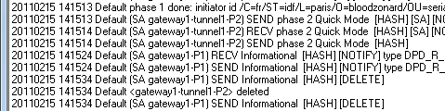

Tools in case of trouble

Configuring an IPsec VPN tunnel can be a hard task. One missing parameter can prevent a VPN connection from being established. Some tools are available to find source of troubles during a VPN establishment.

A good network analyser: Wireshark

Wireshark is a free software that can be used for packet and traffic analysis. It shows IP or TCP packets received on a network card. This tool is available on website www.wireshark.org. It can be used to follow protocol exchange between two devices. For installation and use details, read its specific documentation (www.wireshark.org/docs/).

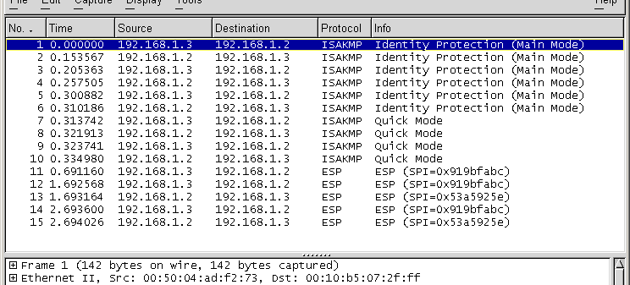

VPN IPsec Troubleshooting

“PAYLOAD MALFORMED” error (wrong Phase 1 [SA])
114920 Default (SA CNXVPN1-P1) SEND phase 1 Main Mode [SA][VID]
114920 Default (SA CNXVPN1-P1) RECV phase 1 Main Mode [NOTIFY]
114920 Default exchange_run: exchange_validate failed
114920 Default dropped message from 195.100.205.114 port 500 due to notification type PAYLOAD_MALFORMED
114920 Default SEND Informational [NOTIFY] with PAYLOAD_MALFORMED error

If you have an “PAYLOAD MALFORMED” error you might have a wrong Phase 1 [SA], check if the encryption algorithms are the same on each side of the VPN tunnel.

“INVALID COOKIE” error
115933 Default message_recv: invalid cookie(s) 5918ca0c2634288f 7364e3e486e49105
115933 Default dropped message from 195.100.205.114 port 500 due to notification type INVALID_COOKIE
115933 Default SEND Informational [NOTIFY] with INVALID_COOKIE error

If you have an “INVALID COOKIE” error, it means that one of the endpoint is using a SA that is no more in use. Reset the VPN connection on each side.

“no keystate” error
115315 Default (SA CNXVPN1-P1) SEND phase 1 Main Mode [SA][VID]
115317 Default (SA CNXVPN1-P1) RECV phase 1 Main Mode [SA][VID]
115317 Default (SA CNXVPN1-P1) SEND phase 1 Main Mode [KEY][NONCE]
115319 Default (SA CNXVPN1-P1) RECV phase 1 Main Mode [KEY][NONCE]
115319 Default (SA CNXVPN1-P1) SEND phase 1 Main Mode [ID][HASH][NOTIFY]
115319 Default IPsec_get_keystate: no keystate in ISAKMP SA 00B57C50

Check if the preshared key is correct or if the local ID is correct (see “Advanced” button). You should have more information in the remote endpoint logs.

“received remote ID other than expected” error
120348 Default (SA CNXVPN1-P1) SEND phase 1 Main Mode [SA][VID]
120349 Default (SA CNXVPN1-P1) RECV phase 1 Main Mode [SA][VID]
120349 Default (SA CNXVPN1-P1) SEND phase 1 Main Mode [KEY][NONCE]
120351 Default (SA CNXVPN1-P1) RECV phase 1 Main Mode [KEY][NONCE]
120351 Default (SA CNXVPN1-P1) SEND phase 1 Main Mode [ID][HASH][NOTIFY]
120351 Default (SA CNXVPN1-P1) RECV phase 1 Main Mode [ID][HASH][NOTIFY]
120351 Default ike_phase_1_recv_ID: received remote ID other than expected support@thegreenbow.fr

The “Remote ID” value (see “Advanced” Button) does not match what the remote endpoint is expected.

“NO PROPOSAL CHOSEN” error
115911 Default (SA CNXVPN1-P1) SEND phase 1 Main Mode [SA][VID]
115913 Default (SA CNXVPN1-P1) RECV phase 1 Main Mode [SA][VID]
115913 Default (SA CNXVPN1-P1) SEND phase 1 Main Mode [KEY][NONCE]
115915 Default (SA CNXVPN1-P1) RECV phase 1 Main Mode [KEY][NONCE]
115915 Default (SA CNXVPN1-P1) SEND phase 1 Main Mode [ID][HASH][NOTIFY]
115915 Default (SA CNXVPN1-P1) RECV phase 1 Main Mode [ID][HASH][NOTIFY]
115915 Default phase 1 done: initiator id c364cd70: 195.100.205.112, responder id c364cd72: 195.100.205.114, src: 195.100.205.112 dst: 195.100.205.114
115915 Default (SA CNXVPN1-CNXVPN1-P2) SEND phase 2 Quick Mode [SA][KEY][ID][HASH][NONCE]
115915 Default RECV Informational [HASH][NOTIFY] with NO_PROPOSAL_CHOSEN error
115915 Default RECV Informational [HASH][DEL]
115915 Default CNXVPN1-P1 deleted

If you have an “NO PROPOSAL CHOSEN” error, check that the “Phase 2” encryption algorithms are the same on each side of the VPN Tunnel.

Check “Phase 1” algorithms if you have this:

115911 Default (SA CNXVPN1-P1) SEND phase 1 Main Mode [SA][VID]
115911 Default RECV Informational [NOTIFY] with NO_PROPOSAL_CHOSEN error

“INVALID ID INFORMATION” error
122623 Default (SA CNXVPN1-P1) SEND phase 1 Main Mode [SA][VID]
122625 Default (SA CNXVPN1-P1) RECV phase 1 Main Mode [SA][VID]
122625 Default (SA CNXVPN1-P1) SEND phase 1 Main Mode [KEY][NONCE]
122626 Default (SA CNXVPN1-P1) RECV phase 1 Main Mode [KEY][NONCE]
122626 Default (SA CNXVPN1-P1) SEND phase 1 Main Mode [ID][HASH][NOTIFY]
122626 Default (SA CNXVPN1-P1) RECV phase 1 Main Mode [ID][HASH][NOTIFY]
122626 Default phase 1 done: initiator id c364cd70: 195.100.205.112, responder id c364cd72: 195.100.205.114, src: 195.100.205.112 dst: 195.100.205.114
122626 Default (SA CNXVPN1-CNXVPN1-P2) SEND phase 2 Quick Mode [SA][KEY][ID][HASH][NONCE]
122626 Default RECV Informational [HASH][NOTIFY] with INVALID_ID_INFORMATION error
122626 Default RECV Informational [HASH][DEL]
122626 Default CNXVPN1-P1 deleted

If you have an “INVALID ID INFORMATION” error, check if “Phase 2" ID (local address and network address) is correct and match what is expected by the remote endpoint.

Check also ID type (“Subnet address” and “Single address”). If network mask is not check, you are using a IPV4_ADDR type (and not a IPV4_SUBNET type).

I clicked on “Open tunnel”, but nothing happens.
Read logs of each VPN tunnel endpoint. IKE requests can be dropped by firewalls. An IPsec Client uses UDP port 500 and protocol ESP (protocol 50).

The VPN tunnel is up but I can’t ping !
If the VPN tunnel is up, but you still cannot ping the remote LAN, here are a few guidelines:
- Check Phase 2 settings: VPN Client address and Remote LAN address. Usually, VPN Client IP address should not belong to the remote LAN subnet
- Once VPN tunnel is up, packets are sent with ESP protocol. This protocol can be blocked by firewall. Check that every device between the client and the VPN server does accept ESP
- Check your VPN server logs. Packets can be dropped by one of its firewall rules.
- Check your ISP support ESP
- If you still cannot ping, follow ICMP traffic on VPN server LAN interface and on LAN computer interface (with Wireshark for example). You will have an indication that encryption works.
- Check the “default gateway” value in VPN Server LAN. A target on your remote LAN can receive pings but does not answer because there is a no “Default gateway” setting.
- You cannot access to the computers in the LAN by their name. You must specify their IP address inside the LAN.
- We recommend you to install Wireshark (www.wireshark.org) on one of your target computer. You can check that your pings arrive inside the LAN.

Contacts

News and updates on TheGreenBow web site: www.thegreenbow.com

Technical support by email at: support@thegreenbow.com

Sales contacts by email at: sales@thegreenbow.com

Secure, Strong, Simple
TheGreenBow Security Software

